Contents

Mailing Lists 2

Car insurance 2

Forums 3

RSS 4

Atom 5

Atom syndication format 5

Atom publishing protocol 5

Mashups (KJ, 2022) 5

Web parts (kj, web part, 2022) 5

Bibliography 6

**3.7**

Networks and data feeds to suit collaborative technology

# Mailing Lists

Are databases with potential contacts for the subject or topic you pursue, such as;

* Business contacts
  + Companies
  + Customers
  + Creditors
  + Suppliers
  + Legal representatives

There are many sites dedicated to helping users find the information they need; the following site is an example;

## Car insurance

For this exercise I shall use the ‘GoCompare’ website;

*The user enters the car details, home address, personal details, and codes a password,*

*the user then gets a mail list, with offers, different elements, and a link to insurance sites.*

# Forums

A forum is an on-line discussion group, where the **user** wants help or opinions on a subject, they will receive message from *people* who have an interest and experience in the subject, however **users** should be aware that *people* in these groups are not necessarily trustworthy, has you do not them personally and they could be anywhere in the world. So, when using a forum, it is best to acknowledge the information with a hesitant approach, perhaps by cross referencing **the feedback** to identify a wider valuation of **the feedback.**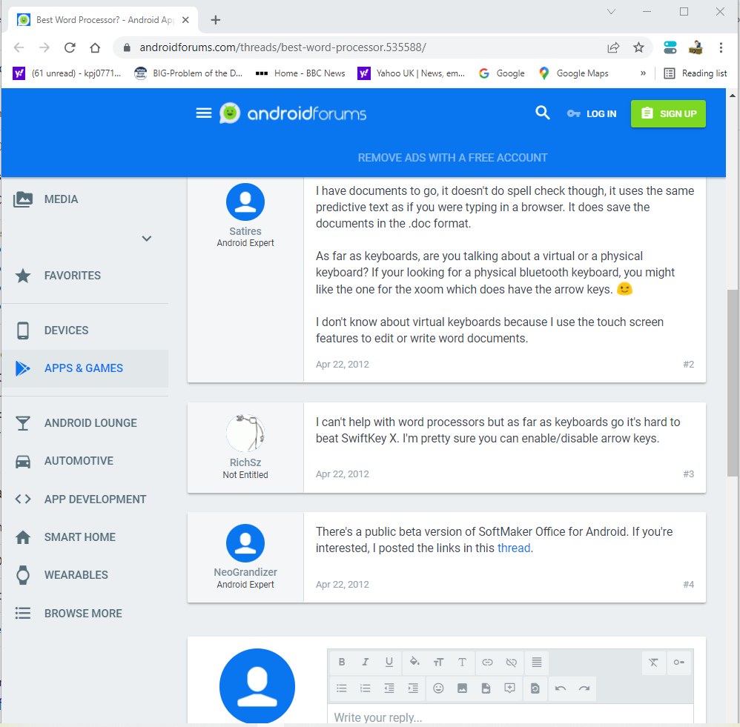

*This site offers opinions from members, the opportunity to reply and other subjects that may be of interest.* (kj, Forum, 2022)

# RSS

RSS [Really simple Syndication], allows users and software applications to update to web sites in a computable-readable format [code].

These web feeds are now outdated, due to more recent sites increased technology, these sites were primarily used by news editorials. They could keep track of many web sites, monitor other sites for new content, allowing the user access to updates information such as blog entries and news headlines, including access to audio, video, and podcasts. The RSS checks the users feeds regularly for new information, and can automatically download associated information, this unfortunately includes downloading related advertisements we now call Cookies. (kj, RSS, 2022)

<https://youtu.be/TU5zc-u6dhY>

# Atom

## Atom syndication format

ASF is an XML language[1], used for web feeds, checks for updates published on the website to provide web feed, the owner may use a **content management system[2]** to publish a list [feed] of recent articles or content in a standardized readable format.

## Atom publishing protocol

A HTTP based protocol[3], for publishing and editing web resources.

<https://youtu.be/lJtq0T1LRbw>

# Mashups (KJ, 2022)

Also known as Hybrid web application, combines services from several web pages to offer a new service. Data integration[4], obtained from APIs[5], uses third party content via public sources to create integrated/hybrid web pages.

<https://youtu.be/bnxIV6IDJ70>

# Web parts (kj, web part, 2022)

Also called a web widget, an ASP.NET[6] server control, allows users to modify content, appearance and behaviour directly from the browser.

<https://youtu.be/iwaXaNzG5M8>

# Bibliography

kj. (2022, April 26). *Forum*. Retrieved from webopedia: https://www.webopedia.com/definitions/forum/

kj. (2022, April 26). *RSS*. Retrieved from wikipedia: https://en.wikipedia.org/wiki/RSS

kj. (2022, April 27). *web part*. Retrieved from Wikipedia: https://en.wikipedia.org/wiki/Web_part

kj. (2022, April). *What is Mashup – Hybrid Web Application*. Retrieved from ARIMETRICS.

KJ. (2022, April 27). *What is Mashup – Hybrid Web Application*. Retrieved from ARIMETRICS: https://www.arimetrics.com/en/digital-glossary/mashup-hybrid-web-application

kj. (2022, April 26). *XML*. Retrieved from Wilipedia: https://en.wikipedia.org/wiki/XML

1. XML-extensible Markup Language, for storing and transmitting arbitrary data, defines a readable[human/computer] format (kj, XML, 2022)
2. CMS- software program- stores & organises contact info [names, addresses, emails etc].
3. HTTP- [Hypertext Transfer Protocol], internet protocol model for distributed, collaborative hypermedia information. Foundation of data communication for the world wide web.
4. Plagiarism?
5. API- [application programming interface], access offered via apps that allow data communication via apps specific language. Acts similar to an intermediary between programmer and an app.
6. ASP.NET an open-source wen-application designed for web development to produce dynamic web pages.